Analytic report template

This analytical report template is designed to simplify the process of creating comprehensive and insightful reports for your business. Whether you're assessing financial health, exploring market trends, or evaluating operational performance, this template provides a structured framework to present your findings clearly and effectively.

Here’s how to use it:

* **Customize to fit your needs:** Modify sections to align with your specific objectives and data. Feel free to add or remove elements to better suit your analysis.
* **Focus on clarity:** Use simple, straightforward language and avoid technical jargon. The goal is to make your report easily understandable for all audiences.
* **Emphasize key findings:** Use the structure to highlight crucial insights. Make sure your conclusions and recommendations stand out.
* **Utilize visual aids:** Incorporate charts, graphs, and tables to represent data visually, making complex information more digestible.
* **Revise and refine:** After completing the first draft, review and refine your report to enhance accuracy, clarity, and impact.

Here are a few resources to help you structure your report:

* [Google Slides](https://docs.google.com/presentation/u/0/?ftv=1&tgif=c)
* [Canva](https://www.canva.com/presentations/templates/)
* [SlidesMania](https://slidesmania.com/)

By following this template and these tips, you can create a powerful analytical report that effectively communicates your findings and drives informed decision-making.

Let’s get started!

Exploratory Data Analysis Salary Report

**Prepared by:** [Sebastian Ramirez Orozco]

**Date:** [Date of Report]

**Prepared for:** [Recruiters and hiring managers]

## Summary

The executive summary is arguably one of the most important parts of any analytic report. It provides a concise overview of the entire report, giving readers a glimpse into what to expect.

The primary purpose of this section is to summarize the key points of your analysis, highlighting major findings and recommendations. This section is significant for readers who may need more time to read the entire document but must grasp the essential insights and conclusions quickly and effectively.

Here’s what you should include:

* **A brief overview:** Summarize the main objectives and scope of the report.
* **Key findings:** Highlight the most important insights discovered during your analysis.
* **Major recommendations:** Outline the primary recommendations or strategic implications based on your findings.

Remember to keep this section short and to the point, usually no more than a page.

## Introduction

Salary, the think we expect every fortnight or maybe monthly. Something very relevant for everyone and that varies from gender, industry, education level, years of experience and maybe even age. Have you ever wondered about this varieties? Or maybe you are an employer and need a reference on how the market for new positions in the future is.

If the answer is yes, this might interest you. I decided to analyze a salary dataset that was obtained from multiple sources including surveys, job posting sites, and other publicly available sources. Said data is hosted Kaggle [here.](https://www.kaggle.com/datasets/mohithsairamreddy/salary-data)

The dataset covers age, gender, years of experience, education level, salary, and job title. About how it is structured, it has six columns, 6705 rows and is a csv file.

Finally, we will aim to answer the following questions:

1. A
2. A
3. A
4. A
5. A
6. A
7. A
8. A
9. A
10. A

## Data Analysis

Project Summary

The main goal of the projects is to perform an exploratory data analysis on Excel and provide an answer to stakeholder’s inquiries.

The project has the following steps:

1. Data Sources and Data Gathering
2. Assessing and Data Cleaning
3. Data Analysis
4. Data Visualization

Project Environment

This project is run entirely through Excel. All calculations, cleaning and visualization are going to be perform using Excel and Power Query. Dataset must be downloaded from Kaggle and imported to Excel using the import from text/csv option on the data tab.

Step 1. Data Sources and Data Gathering

**Data Sources**

* Salary Data (Kaggle)

**Data Gathering**

The dataset was obtained from multiple sources, including surveys, job posting sites, and other publicly available sources. A total of 6704 data points were collected. The dataset included five variables: age, experience, job role, and education level and salary.

Step 2. Assessing and Data Cleaning

**Importing Data and Transformation**

* Data is imported using the import from text/csv option on the data tab.
* We will be met with a confirmation window to import the dataset. Here we will click the transform data button.

**Handle Missing Values and Outliers**

* To identify missing values, null values, or errors we will check the column quality and column profile on the view tab. Also, filtering each column and selecting said values will give a good overview of what needs to be fixed.



* There are two whole rows empty which we will delete using the remove blank rows option from the home tab.
* Now we only have some rows with only one or more cell empty. We will proceed to imputation.
* Education level column only have one missing value, the way to proceed is through a Frequent Categorical Imputation. The reason behind this is because it is only one row, so bias is minimal and for its simplicity. The way to do it is using replace values from “” to Bachelor’s and check the match entire cell contents option.
* While filtering years of experience and salary we find tree rows with missing values as shown below.

We will impute these missing values using simple imputation with mean or average of each column.

Note 1. To perform calculations as mean we need to convert the column salary and years of experience to whole number and decimal number first. To do it just click on the left symbol that it’s next to the column name.

Note 2. While filtering both columns I identified some possible outliers on the salary column and are limited to 4 records only. These probably are due to human error. Also, there are very few records on the years of experience column with decimal numbers.

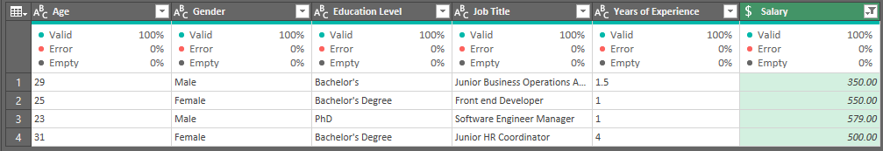

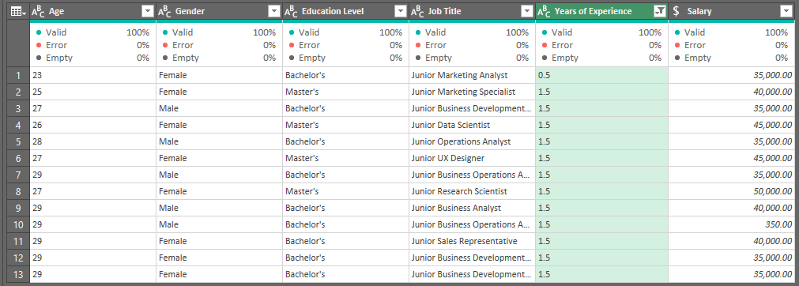

Note 3. I decided to impute the outliers using again simple imputation with the mean as the replaced value.

* As the last step, if we look at the categories on the education level column, we can see a redundancy. To fix this, replace values must be used.

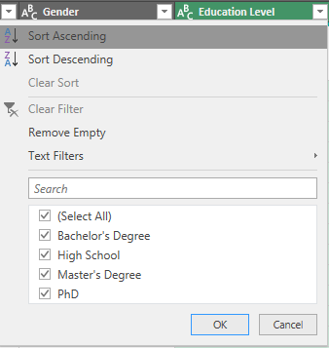

**Address Duplicate Records**

* To remove the duplicated records first we will use the keep duplicates option from the home tab to have an idea of what exactly is duplicating. Now we will use the remove duplicates.

Note 1. After carefully assessing the data while removing duplicates, I have concluded that most of data is duplicated. If I remove all this records, the dataset will be left with only 1792 of the 6704 original rows, which represents 73.2 % of all the data. For the sake of continuing with the analysis, I will keep all the records.

**Standardize Data Formats**

* Now we will ensure consistency in data formats across different columns or variables. Here we must check for spelling errors, fixing number format, removing non-printable characters, changing text case and formatting data as a table if applicable.

For spelling we will use the spelling option on the review tab. We can change the salary, years of experience and age format on the number format that is on the home tab. To remove non-printable characters, removing spaces and changing the text case we can just copy the columns and use the functions:

=CLEAN (XX)

=PROPER(XX)

=TRIM(CLEAN((SUBSTITUTE(XX,CHAR(160)," "))))

Note 1. Each time you copy a column with functions you must paste it as value so you don’t lose the reference.

With this we are ready to star analyzing the data. This is how it looks after al the cleaning on Excel.

Step 3. Data Analysis

Step 4. Data Visualization

The data analysis section is where you delve into the heart of your report, examining and interpreting the collected data. This part of your report should demonstrate a thorough, methodical approach to analyzing the data, with an emphasis on uncovering meaningful insights.

It’s crucial to present the data in a way that's both understandable and compelling, especially for key decision-makers and investors. The challenge here is to distill complex data into clear, digestible information without oversimplifying or omitting crucial details.

Here’s what should be included in this section:

* **Relevant data:** Include data that directly contributes to your objectives and supports your findings.
* **Organized data presentation:** Structure your data logically, grouping related information together.
* **Effective data visualization:** Use charts, graphs, and tables where they can clarify and emphasize key points. Remember, the goal is to make your data as easy to understand as possible.
* **Explanation of methods:** Briefly describe how you analyzed the data, including any specific techniques or software used.
* **Critical analysis:** Don’t just describe your data — offer insights into what the data means for your business.

Not all data is useful, and it’s important to be specific and concise about the data you choose to present. So, how do you decide what to include or leave out? Here are some tips:

* **Stay on-topic:** Include data that directly impacts your objectives. If data doesn't support your main points or objectives, it's likely best left out — even if it’s interesting.
* **Avoid information overload:** Too much data can overwhelm and confuse the reader. Be selective and focus on what’s most important.
* **Keep it clear and impactful:** Choose data that can be clearly presented and has the most significant impact on illustrating your points.

## Findings

This is where you synthesize the data you just analyzed into strong, direct conclusions. Here, you present the ‘so what’ of your report — the implications and significance of your analysis. It's about distilling your data into meaningful insights that directly address your report's objectives. This section should build on your data analysis by translating the raw data and trends into understandable and actionable conclusions.

Here’s what you need to include:

* **Summary of key insights:** Distill your analysis into the most crucial insights.
* **Connection to objectives**: Explicitly link these insights back to the report’s objectives.
* **Direct implications:** Discuss the direct implications of these findings on your business or the specific situation.
* **Visual aids:** Use charts or graphs to help you communicate these findings as needed — but be sure to differentiate your visual aids from any used in the data analysis section.

Remember, the easier it is to understand, the better. Present your findings in a straightforward way to limit confusion and help readers get to your point quickly and easily.

## Recommendations

The recommendations section is where you turn insights into action! Based on the findings from your analysis, this part of the report proposes specific, actionable strategies or steps that the business should consider.

The goal is to offer practical, well-founded recommendations that can help in decision-making processes, address identified issues, or capitalize on opportunities. This section should be direct, focusing on providing clear guidance backed by the data and findings presented earlier.

Here’s what to include in this section:

* **Actionable suggestions:** Offer clear, practical recommendations based on your findings. Readers should be able to know exactly what their next steps are when they’re finished with this section.
* **Short-term and long-term recommendations:** Distinguish between immediate actions and longer-term strategies, making it clear that the recommendations hold value over an extended period.
* **Justification for each recommendation:** Provide a rationale for why each recommendation is made, linking back to specific findings from previous sections of the report.
* **Consideration of different scenarios:** Offer alternatives where applicable, considering different business scenarios or contingencies.

It can be difficult to differentiate the recommendations and findings sections. Here’s an easy way to think about it:

* **In the findings section:** Focus on what the data reveals — the insights and trends.
* **In the recommendations section:** Shift to what should be done about these insights — the specific actions or strategies.

By providing well-structured and data-backed recommendations, this section of your report can significantly influence decision-making and strategic planning. It's about turning insights into tangible results!

## Conclusion

The conclusion is where you tie together all the elements of your report into a cohesive summary. This part should not only recap the main insights and recommendations but also emphasize their practical implications.

The aim is to leave your readers, especially stakeholders and decision-makers, with a clear sense of direction and understanding of the next steps. An effective conclusion reiterates the report's value and encourages action, ensuring that the report leads to tangible outcomes.

Here’s what you need to include in your conclusion:

* **Summary of key points:** Concisely recap the main insights from the findings and the core recommendations.
* **Call to action:** Clearly state the next steps that should be taken based on the report’s conclusions.
* **Reflection on the report's significance:** Emphasize the importance of the report in relation to business strategy, growth, or other objectives.
* **Encouragement for decision-making:** Urge readers to act on the report's recommendations, highlighting the potential benefits of doing so.

Here are some tips for emphasizing actionability:

* **Make it specific:** Detail exactly what actions need to be taken next. Avoid vague or general statements.
* **Link to objectives:** Reinforce how these actions align with the overall business objectives or goals.
* **Highlight urgency:** If applicable, stress the urgency of taking action, particularly if there are time-sensitive opportunities or risks.

The conclusion should serve as a powerful endnote to your report, driving home the importance of the findings and recommendations, and spurring readers into action.

## Appendices

This section is essential for including supplementary material that supports your main report but is too detailed or extensive for the body of your presentation.

This section adds depth to your report, providing the raw data, technical details, or extended analysis that underpins your findings and recommendations. It's particularly important for readers who want to delve deeper into your methodology or verify the data sources.

Here’s what you should include:

* **Extended data sets:** Include full data tables or raw data that were summarized or referenced in the report.
* **Detailed methodological information:** Provide thorough descriptions of any complex methodologies or analytical processes used.
* **Supporting documents:** Add any relevant documents, such as full survey results, interview transcripts, or additional graphs and charts.
* **Technical specifications:** For reports involving technical products or processes, include detailed specifications or technical drawings.

## References

The references section helps you maintain the credibility and integrity of your report. It lists all the sources, tools, and materials you used in your analysis.

This section is vital for readers who want to validate the information presented or further explore the topics covered. It demonstrates transparency and adherence to academic and professional standards.

Here’s what needs to be included:

* **Source citations:** List all sources of data, literature, or information used in your report. This includes books, articles, websites, and market research.
* **Tool citations:** Mention any tools or software used for data analysis, like Expensify, or any other industry-specific tools.
* **Acknowledgments:** If applicable, acknowledge any assistance or contributions from experts, consultants, or others who helped with the report.